Chapter 5, Solution 54.
The first stage is a summer (please note that we let the output of the first stage be v₁).

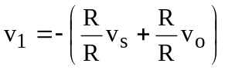 = –v_{s} – v_{o}

The second stage is a noninverting amplifier

v_{o} = (1 + R/R)v₁ = 2v₁ = 2(–v_{s} – v_{o}) or 3v_{o} = –2v_{s}

v_{o}/v_{s} = –0.6667.

